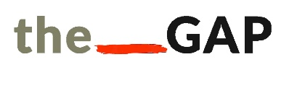 |  |  |  |  |  |  | DIRECT DEBIT FORM
Please complete all of this form and return it to the following address:
The GAP Arts Project, 498-500 Moseley Road, Balsall Heath, Birmingham, B12 9AH.
Queries relating to finance or this form: |  |  |  | Telephone: 07866 174 704 |  |  |  |  |  | Email: maria@thegapartsproject.co.uk
I would like to make a regular gift to The GAP Arts Project, Registered Charity No: 1156090.
Mr/Mrs/Ms/Miss | First Name: |  |  |  |  |  |  |  | Last Name:
Address and Postcode:
Telephone Number: |  |  |  |  |  | Email Address:
I would like to give | £ |  |  |  | per month/year starting on |  |  |  |  |  |  | __ __ / __ __ / __ __ __ __  Day Month Year
Gift Aid Declaration: I wish The GAP Arts Project to treat all donations I have made in the past 4 years, and any future donations I make from now on, as Gift Aid donations. By ticking this box I confirm that I am a UK taxpayer and have paid an amount of income or capital gains tax (VAT and council tax do not apply) at least equal to the tax that all charities, clubs and societies that I donate to will reclaim on my donations in the appropriate tax year (currently 25p for every £1 given).
If your name, address or tax circumstances change please let us know.
We will never pass your details on to any other organisation and we will treat them with respect. By giving us your email address and telephone number, you agree that we may use them to send you information about The GAP Arts Project. If you do not wish to receive any further information, please tick this box. (Please note this does not include further contact in relation to this form.)
Instruction to your Bank or Building Society to pay by Direct Debit:
To: The Manager | Bank/Building Society Name:
Bank Address and Postcode:
Account Number: |  |  |  |  |  |  | Sort Code:
Please pay The GAP Arts Project Direct Debits from the account detailed in this instruction subject to safeguards assured by the Direct Debit Guarantee. I understand that this instruction may remain with The GAP Arts Project and, if so, details will be passed electronically to my Bank/ Building Society.
Name(s) of Account Holder(s):
Signature(s):
Date of signing:
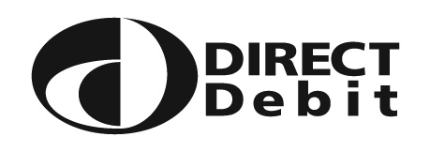
The Direct Debit Guarantee:
- This Guarantee is offered by all banks and building societies that accept instructions to pay Direct Debits.
- If there are any changes to the amount, date or frequency of your Direct Debit The GAP Arts Project will notify you 10 working days in advance of your account being debited or as otherwise agreed. If you request The GAP Arts Project to collect a payment, confirmation of the amount and date will be given to you at the time of the request.
- If an error is made in the payment of your Direct Debit, by The GAP Arts Project or your bank or building society, you are entitled to a full and immediate refund of the amount paid from your bank or building society – if you receive a refund you are not entitled to, you must pay it back when The GAP Arts Project asks you to.
- You can cancel a Direct Debit at any time by simply contacting your bank or building society. Written confirmation may be required. Please also notify The GAP Arts Project.

